**ONLINE FOOD ORDERING APP UI**

**INTERDISCIPLINARY PROJECT**

Submitted in partial fulfillment of the requirements for the award of Bachelor of Engineering degree in Computer Science and Engineering

By

**Gogina Jogeswar venkat sai**

**Reg. No–42110372**



**DEPARTMENT OF COMPUTER SCIENCE AND ENGINEERING**

# SCHOOL OF COMPUTING

SATHYABAMA

## INSTITUTE OF SCIENCE AND TECHNOLOGY (DEEMED TO BE UNIVERSITY)

**CATEGORY - 1 UNIVERSITY BY UGC**

**Accredited with Grade “A++” by NAAC I Approved by AICTE JEPPIAAR NAGAR, RAJIV GANDHI SALAI, CHENNAI - 600119**

## APRIL - 2025



**DEPARTMENT OF COMPUTER SCIENCE AND ENGINEERING**

**BONAFIDE CERTIFICATE**

This is to certify that this Interdisciplinary Project Report is the bonafide work of

**Gogina Jogeswar venkat sai(Reg. No–42110372)** who carried out the Project entitled **“ONLINE FOOD ORDERING APP UI”** under my supervision from January 2025 to April 2025.

**Internal Guide**

**Ms.J.JOAN NIVEDA, M.E., (Ph.D.)**

**Head of the Department**

**Dr. L. LAKSHMANAN, M.E., Ph.D.,**

Submitted for Interdisciplinary Project Viva Voce Examination held on-----------------------

**Internal Examiner External Examiner**

## DECLARATION

I,**Gogina Jogeswar venkat sai (Reg. No–42110372)**, hereby declare that the Interdisciplinary Project Report entitled “ONLINE FOOD ORDERING APP UI” done by me under the guidance of **Ms.J.JOAN NIVEDA, M.E., (Ph.D.),** is submitted in partial fulfillment of the requirements for the award of Bachelor of Engineering degree in **Computer Science and Engineering.**

## DATE:

**PLACE: Chennai SIGNATURE OF THE CANDIDATE**

## ACKNOWLEDGEMENT

I am pleased to acknowledge my sincere thanks to **Board of Management** of **Sathyabama Institute of Science and Technology** for their kind encouragement in doing this project and for completing it successfully. I am grateful to them.

I convey my thanks to **Dr. T. Sasikala M.E., Ph. D**, **Dean**, School of Computing, and **Dr. L. Lakshmanan M.E., Ph.D.,** Head of the Department of Computer Science and Engineering for providing me necessary support and details at the right time during the progressive reviews.

I would like to express my sincere and deep sense of gratitude to my Project Guide

**Ms.J.JOAN NIVEDA M.E., (Ph.D).** for her valuable guidance, suggestions, and constant encouragement paved way for the successful completion of my project work.

I wish to express my thanks to all Teaching and Non-teaching staff members of the **Department of Computer Science and Engineering** who were helpful in many ways for the completion of the Interdisciplinary project.

**TRAINING CERTIFICATE**



## ABSTRACT

This mini project presents the design and development of a **Food Ordering Application User Interface (UI)** aimed at enhancing the digital food ordering experience. The application interface allows users to seamlessly explore a variety of food items, select from different categories, add items to the cart, and proceed to checkout with ease. The focus of the project is on creating a **clean, intuitive, and user-friendly UI** that offers smooth navigation and a visually appealing layout. Key screens such as the home page, restaurant/food listing, item details, cart, and user profile are designed to simulate the user journey in a typical food ordering process. Modern UI/UX principles have been applied using design tools/frameworks such as [mention your tools – e.g., Figma, Flutter, React Native, etc.], ensuring responsiveness and accessibility across different devices. Though this project does not include backend or database integration, it provides a strong foundation for future development of a fully functional food ordering app. The project serves as a practical implementation of front-end design concepts and showcases how thoughtful UI can improve user engagement and satisfaction in mobile application. Accessibility considerations were taken into account to ensure that the app design is inclusive and usable by people of all abilities. Elements such as readable fonts, clear icons, and consistent layouts were implemented to enhance the user experience for everyone.

## TABLE OF CONTENTS

**CHAPTER NO.**

**TITLE PAGE**

**ABSTRACT** v

**NO.**

**LIST OF FIGURES** vii

1. INTRODUCTION 1
2. AIM AND SCOPE OF THE PRESENT INVESTIGATION
   1. AIM 7
   2. SCOPE 7
3. ANALYSIS 
   1. USER RESEARCH 9
4. METHOD AND IMPLEMENTATION
   1. DESIGN APPROACH 12
   2. IMPLEMENTATION 13
5. RESULTS AND DISCUSSION
   1. PROTOTYPE 16
   2. SUMMARY 17

5.3 CONCLUSION 18

5.4 SAMPLE SCREENSHOTS 19

REFERENCES 22

# 

# LIST OF FIGURES

**FIG NO FIGURE NAME PAGE NO**

* 1. FIGMA EDITOR 1
  2. FIGMA TOOLBAR 2
  3. FIGMA CANVAS 2
  4. FIGMA FRAME 3
  5. LAYERS PANEL 4
  6. PROPERTIES PANEL 4
  7. DESIGN VS PROTOTYPE 5

5.1 PROTOTYPING 16

**CHAPTER 1**

**INTRODUCTION**

**1.1.WHAT IS FIGMA ?**

Figma is a web-based graphics editing and user interface design app. You can use it to do all kinds of graphic design work from wire framing websites, designing mobile app interfaces, prototyping designs, crafting social media posts, and everything in between. Figma is different from other graphics editing tools. Mainly because it works directly on your browser. This means you get to access your projects and start designing from any computer or platform without having to buy multiple licenses or install software. Figma is a browser-based design software that is used in many contexts, such as UX design, UI design, and graphic design.

* **Figma Editor**

In Figma, the editor is the workspace where projects are created, edited, shared, and reviewed. The editor consists of four main components: toolbar, layers panel, properties panel, and canvas.

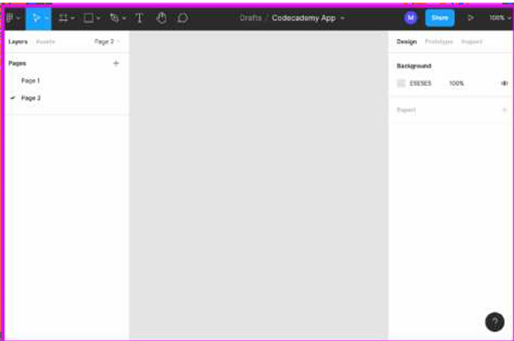

Fig 1.1 Figma editor

* **Toolbar**

The toolbar, located at the top of the Figma editor, provides tools for adding objects on the canvas and moving them around. There are also tools for collaboration and review.

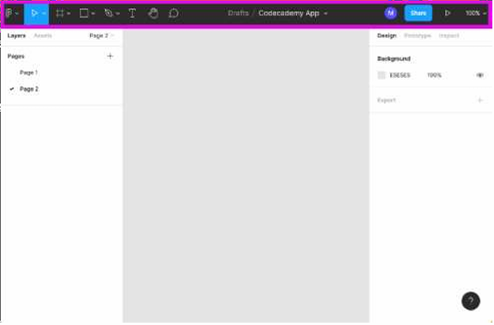

**Fig 1.2 Figma toolbar**

* **Canvas**

The grey area in the middle of the Figma editor is the canvas. As objects are added to the design file, they appear on the canvas as layers.

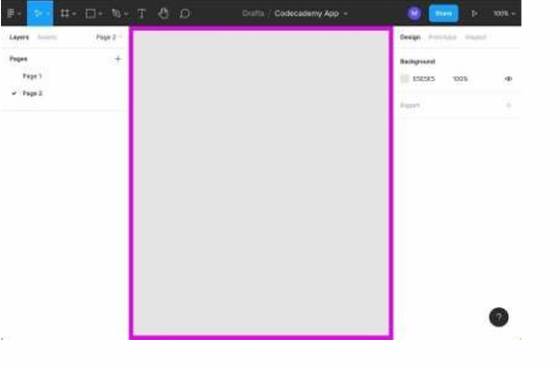

**Fig 1.3 Figma canvas**

* **Layer**

In Figma, any object that is added to the canvas is considered a layer. Frames, shapes, text, and images are all considered layers.

* **Frame**

In Figma, a frame is a layer that holds other layers. While custom frames can be created, many premade options are available, such as frames that are the dimensions of a smartphone, tablet, or laptop screen. In Figma, you can add layers directly to the Canvas. If you're designing for a specific device or screen size, you may want to create a container for your designs. This is where frames come in. If you've used design tools before, you'll be familiar with art boards. Like art boards, frames allow you to choose an area of the canvas to create your designs in. Unlike traditional artboards, you can also nest frames within other frames. This allows to create more complex design that work together. Frames also give you access to extra functionality, like Layout grids, Auto Layouts, Constraints and prototyping.

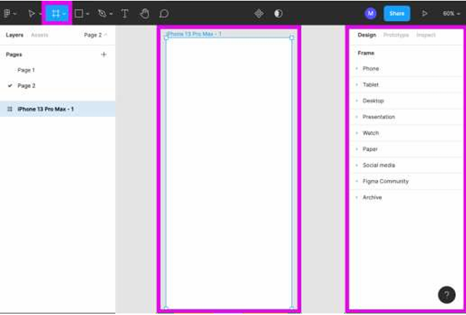

**Fig 1.4 Figma frame**

* **Layers Panel**

The layers panel is located on the left sidebar of the Figma editor, it displays a Dynamic list of all layers as they are added to the canvas.

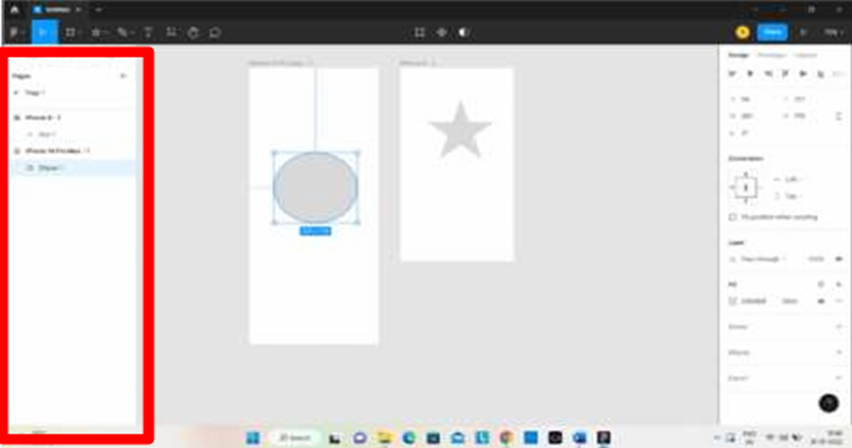

**Fig 1.5 layers panel**

* **Properties Panel**

The properties panel is located on the right side of the Figma editor, it provides a multitude of options for adjusting and manipulating the properties of layers that have been added to the canvas.

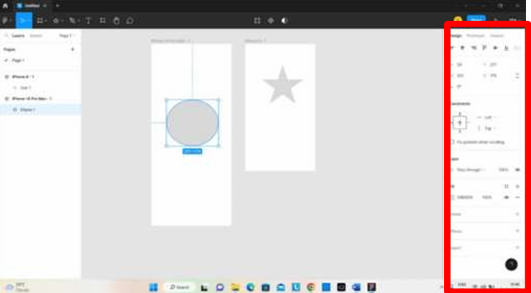

**Fig 1.6 Properties panel**

* **Design vs. Prototype Mode**

In the Figma editor, **Design mode** has tools for creating designs. **Prototype mode** has features for turning designs into interactive prototypes.

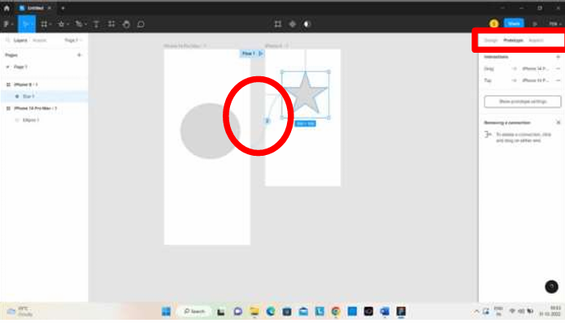

**Fig 1.7 design vs. prototype**

**1.2 .DESIGNING A ONLINE FOOD ORDERING APP**

A food ordering app should offer a smooth and intuitive user experience with features like easy sign-up/login, location-based restaurant discovery, a clean home screen with search and filters, detailed restaurant pages with menus and images, a seamless cart and checkout process with multiple payment options, real-time order tracking, and a user profile for managing order history, favorites, and addresses. The UI should be clean and image-focused, with familiar icons and accessible design. On the backend, it can be built using technologies like React Native or Flutter for the frontend, Node.js or Django for the backend, and integrated with real-time tracking, payment gateways, and push notifications. Optional features like AI-based recommendations, loyalty programs, and voice ordering can enhance the experience further.

In an increasingly digital and convenience-driven world, the demand for online services has skyrocketed—especially in the food industry. With busy lifestyles, long work hours, and the need for quick, reliable meals, online food ordering has become a staple for many users. Our project, titled *"Online Food Ordering App UI,"* is a response to this growing trend. It focuses on crafting a modern, efficient, and aesthetically pleasing user interface that simplifies the food ordering process.

The core objective of this project is to design an intuitive and engaging app interface that enables users to effortlessly browse nearby restaurants, explore diverse menus, place orders, and track deliveries—all from the comfort of their mobile devices. Instead of developing the backend or coding functionalities, this project emphasizes *UI/UX design*, demonstrating how effective visuals and user-centric layouts contribute to the overall user experience.

The design process began with research into user behaviors and expectations. Based on that, we created wireframes and mockups using professional design tools like Figma and Canva. Each screen is structured to minimize user effort and enhance clarity, offering features like categorized menus, real-time cart updates, personalized recommendations, and smooth transitions.

**CHAPTER 2**

**AIM AND SCOPE OF THE PRESENT INVESTIGATION**

**2.1.AIM**

The aim of the online food ordering app is to provide a convenient, efficient, and user-friendly platform for customers to browse restaurant menus, place food orders, and have meals delivered to their doorstep or prepared for pickup. The app is designed to streamline the ordering process, enhance customer satisfaction, and support restaurants in managing and increasing their sales.

**2.2.SCOPE**

The online food ordering app aims to simplify and enhance the food ordering experience for customers, restaurants, and delivery personnel. It offers a digital platform where users can browse nearby restaurants, view menus, place orders, and track deliveries—all from their mobile device or computer. The app connects customers with restaurants and delivery agents in real time, making food ordering efficient, fast, and user-friendly.

The app supports secure user registration, multiple payment options, real-time order tracking, and a feedback system. Restaurants can manage their menus, accept or reject orders, and analyze customer data. Delivery agents get live navigation and status updates for assigned deliveries. Admins oversee the entire system, manage users, resolve issues, and generate reports.

This system is scalable, secure, and accessible across Android, iOS, and web platforms. It provides a complete end-to-end solution for digital food ordering and delivery management.

**Key Features**

**2.2.1.For Customers:**

* User registration & login
* Browse restaurants & menus
* Place orders (delivery or pickup)
* Multiple secure payment options
* Live order tracking
* Ratings & reviews

**2.2.2.For Restaurants:**

* Profile & menu management
* Order notifications and management
* View sales & customer feedback

**2.2.3.For Delivery Agents:**

* Login & order assignments
* GPS navigation & status updates

**2.2.4.For Admins:**

* Manage users, restaurants, and delivery staff
* Handle complaints & feedback
* Generate usage and sales reports

**2.2.5.Technical Highlights:**

* Cross-platform (Android, iOS, Web)
* Scalable & secure architecture
* Push notifications & real-time updates.

**CHAPTER 3**

**ANALYSIS**

**3.1.USER RESEARCH**

**1. Research Objectives**

The primary goal of this user research is to gain a comprehensive understanding of how users interact with online food ordering platforms, what drives them to use such services, and what challenges they face throughout the process. Specifically, we aim to identify the pain points users experience when browsing, selecting, ordering, and receiving food through an app. Additionally, this research seeks to uncover the motivations behind food ordering behaviors, such as convenience, promotions, or lack of time to cook, and understand the expectations users have for app performance, delivery time, and restaurant variety. This will help inform product decisions, improve the user experience, and shape the app’s core features and value proposition.

**2. Target Users**

To capture a well-rounded view of the online food ordering experience, it is crucial to engage a diverse group of users. This includes frequent users who order food several times a week, occasional users who may order once or twice a month, and first-time or non-users who might rely on alternative methods such as calling restaurants or dining in. The target audience should also represent various age groups, income levels, dietary preferences (e.g., vegan, gluten-free), and geographic locations (e.g., urban, suburban, and rural areas) to ensure that the research findings are inclusive and applicable to a broad user base. Understanding these segments will help tailor the app to different needs and preferences.

**3. Research Methods**

To gather meaningful insights, a combination of qualitative and quantitative research methods will be employed.

Surveys will be used to collect data from a larger audience. These structured questionnaires will help identify patterns in food ordering behavior, frequency of usage, favorite platforms, reasons for using or not using apps, and key decision-making factors such as delivery fees, discounts, speed, and restaurant ratings. Tools like Google Forms or Typeform can be used to deploy these surveys effectively.

User Interviews will allow for deeper exploration into individual user experiences. By conducting one-on-one interviews, we can understand the emotional and practical aspects of ordering food online. Interviewees will be asked to describe their last food ordering experience, the app they used, what they liked or disliked about the process, and what could have made the experience better. These conversations are crucial for capturing insights that surveys alone might miss.

Usability Testing will be carried out if a prototype or MVP of the app exists. Participants will be asked to perform common tasks—such as searching for a restaurant, customizing an order, and completing checkout—while speaking their thoughts aloud. Observing their behavior will help identify usability issues, confusing interfaces, or features that don’t align with user expectations.

Competitor Analysis will complement direct user research by studying the strengths and weaknesses of leading food delivery apps such as Uber Eats, DoorDash, Zomato, and Swiggy. This involves analyzing their user interfaces, key features, customer reviews, pricing strategies, and app store ratings. The goal is to identify industry standards as well as gaps where our app can differentiate itself.

**4. Data Analysis & Synthesis**

After data collection, the next step involves analyzing and synthesizing the findings to generate actionable insights. Thematic analysis will be used to categorize qualitative data into common themes, which can be organized using affinity diagrams. Personas will be created to represent typical users, each with specific goals, behaviors, and frustrations related to food ordering. A user journey map will help visualize the full ordering process from the user’s perspective, highlighting key touchpoints, emotions, and pain points encountered at each stage—from deciding to order food to receiving the delivery. These artifacts will guide product design and feature prioritization.

**5. User Behavior Patterns**

users prefer **ordering from recently viewed or previously ordered restaurants**, so having a "Repeat Order" or "Order Again" option would improve convenience

During lunchtime and dinner hours, users are in a rush—**quick load time and fewer screens** are crucial.

Most users **don’t read long descriptions**—they rely on food images, price, and ratings to make quick decisions.

1. ****Emotional Triggers****

* Users often feel overwhelmed by too many options. Minimalistic design and **smart recommendations** can reduce decision fatigue.
* A sense of **urgency or deals**, such as “Limited time offer” or “Only 2 left,” increases user engagement and conversions.
* Users appreciate **friendly micro-interactions** (e.g., animation when food is added to the cart, fun order confirmation messages).

1. **Accessibility Feedback**

* Some users found text in certain apps hard to read due to **poor contrast or small font sizes**. So we focused on readable typography and high contrast in our design.
* **Voice search** is gaining popularity, especially among older users or during hands-busy situations.

1. **Device Usage Patterns**

* 90% of users order via **smartphones**, while only a small percentage use tablets or desktops.
* Vertical scrolling is more preferred than horizontal swiping when browsing food menus

1. ****User Expectations from UI****

* A **real-time delivery estimate** is considered more helpful than just an order confirmation.
* Users expect to see **calorie counts** or basic nutritional info—especially for health-conscious customers.
* **Dark mode** is increasingly requested to reduce eye strain during night-time ordering.

#### **10.** **Loyalty & Personalization**

* Users prefer apps that **remember their preferences** (e.g., spicy level, favorite dishes).
* Built-in **reward points or loyalty programs** increase the chance of repeat usage.

To design a user-friendly and intuitive interface for the Online Food Ordering App UI, a focused user research phase was conducted. The aim was to understand user expectations, common challenges faced while using food delivery apps, and preferences in terms of layout and functionality. Data was gathered through informal interviews, surveys, and competitor analysis of popular apps like Zomato, Swiggy, and Uber Eats. Our primary target users included college students, working professionals, and busy individuals who frequently order food online.

The research revealed that users value speed, simplicity, and clarity in a food ordering experience. Most users preferred quick access to their favorite meals, a clean layout, and features such as restaurant filtering, quick add-to-cart buttons, and order history. Users also appreciated having food images, ratings, and estimated delivery times clearly visible before making a decision. However, we also discovered several areas for improvement that are often overlooked in existing platforms. For example, users expressed frustration with cluttered interfaces, small font sizes, and too many options that lead to decision fatigue.

Additionally, accessibility and personalization emerged as important themes. Many users preferred larger text, better color contrast, and the option for dark mode, especially when ordering at night. Health-conscious users showed interest in having calorie or nutritional information displayed alongside food items. There was also strong interest in loyalty features, such as rewards, personalized recommendations, and a seamless reorder option. These insights played a crucial role in shaping the UI layout, ensuring that the design not only looks good but also aligns with real user needs and behavior patterns.

To further strengthen the design approach, behavioral trends such as peak ordering times and preferred devices were also analyzed. Most users tend to place food orders during lunch (12–2 PM) and dinner hours (7–10 PM), which means the app must load quickly and allow users to place an order in just a few taps. Since the majority of users access food delivery services through smartphones, the design was optimized for mobile-first interaction, emphasizing vertical scrolling and touch-friendly elements. Incorporating subtle animations and micro-interactions—such as visual feedback when adding an item to the cart—was also inspired by user feedback, helping make the experience more lively and engaging. This research-driven design process ensures that the interface is not only visually appealing but also functional and intuitive under real-world usage conditions.

**CHAPTER 4**

**METHOD AND IMPLEMENTATION**

**4.1.DESIGN APPROACH**

Build a user-friendly platform for customers to order food online, restaurants to manage orders, and delivery agents to fulfill deliveries.

The design approach for the Food Ordering App UI is rooted in a user-centered, iterative design philosophy, ensuring the interface caters to the distinct needs of customers, restaurant owners, and delivery personnel. The process begins with comprehensive user research to understand pain points, motivations, and behaviors, followed by the creation of user personas and journey maps that visualize each step of the ordering and delivery process. With a mobile-first mindset, the UI is designed to perform smoothly on smartphones while remaining responsive across tablets and desktops. Emphasis is placed on minimalistic design and intuitive navigation, using visual hierarchy, iconography, and whitespace to guide user flow and reduce decision fatigue. A consistent design system—including reusable components, a color palette aligned with brand identity, accessible typography, and scalable spacing rules—ensures visual harmony and development efficiency. Accessibility is a core focus, with compliance to WCAG guidelines through features like high contrast ratios, voice support readiness, and screen-reader compatibility. The app integrates micro-interactions and motion design to provide subtle feedback and enhance engagement without being distracting. Prototyping is done using tools like Figma or Adobe XD, allowing for quick wireframing, stakeholder reviews, and user testing. Feedback loops are built into the design cycle, enabling continuous iteration and refinement. The final goal is to deliver a delightful, frictionless, and inclusive user experience that meets functional needs while fostering trust and satisfaction.

**4.2. WIREFRAME OF THE PROJECT**

**1. Welcome / Login Screen**

* **Logo**
* **Login Button**
* **Sign Up Button**
* **Continue as Guest**

**2. Home Screen**

* **Top Navigation Bar:**
* Search Bar (e.g., "Search dishes or restaurants")
* Location Selector
* Cart Icon (with item count badge)

1. **Hero Section:**

* Promo Banner (carousel)

1. **Categories:**

* Scrollable icons (e.g., Pizza, Sushi, Burgers, Desserts)

1. **Popular Restaurants / Dishes:**

* Cards with:
* Image
* Name
* Rating
* Estimated Delivery Time
* Price Range

1. **Bottom Navigation Bar:**

Home | Orders | Favorites | Profile

**3. Restaurant / Dish List Screen**

* **Restaurant Banner**

1. **Restaurant Details:**

* Name
* Rating
* Delivery Time
* Free Delivery / Offers

**Menu List (with Tabs for categories):**

* Dish Card:
* Image
* Name
* Description
* Price
* Add to Cart Button (+/- quantity)

**4. Cart Screen**

* **List of Items**
* Dish name, qty, price
* Remove / Edit options
* Subtotal, Taxes, Delivery Fee
* Promo Code Field
* Total
* Checkout Button

**5. Checkout / Payment Screen**

* Delivery Address
* Change / Add New Address
* Payment Methods:
* Card / UPI / COD / Wallet
* Review Order
* Place Order Button

**6. Order Tracking Screen**

* Progress Bar:
* Order Received → Preparing → Out for Delivery → Delivered
* Estimated Delivery Time
* Driver Contact Info + Ma**p**

**7. User Profile Screen**

* Profile Pic, Name
* Order History
* Payment Methods
* Addresses
* Settings
* Help & Support
* Logout

The development process for the Online Food Ordering App UI was carefully planned and executed using a user-centered, design-thinking approach. This methodology is particularly suitable for UI/UX projects, as it focuses on understanding the user's needs at every step. The journey began with a phase of discovery, where user behavior and preferences were studied through questionnaires, informal interviews, and competitor app analysis. This research phase revealed pain points in existing food ordering platforms, such as overwhelming layouts, complicated navigation, and inconsistent UI components. By focusing on real user feedback, we could identify what users truly value—simplicity, speed, personalization, and visual clarity.

Following this, the ideation and planning phase began. During this stage, the user flow of the app was sketched out, keeping in mind how a typical user might interact with the system—from launching the app to placing an order and providing feedback. The flow was intentionally kept simple to reduce cognitive load and improve efficiency. Once the structure was defined, we moved on to creating wireframes. Wireframing is a crucial step in any design process as it allows us to map out the app's skeleton before investing time in detailed design elements. These wireframes focused on layout, functionality, and usability, without getting distracted by colors or stylistic elements.

Wireframes were created for each essential screen in the app, including the splash screen, login/signup, home page, restaurant listings, menu display, cart, checkout, order tracking, and feedback page. Each screen was designed with consistency in spacing, button size, font hierarchy, and alignment to promote a cohesive visual experience. For example, the home screen showcases quick access icons for food categories, trending dishes, and featured offers, while the restaurant listing page allows users to filter by rating, price, or cuisine. The menu screen was designed to allow users to easily browse, customize, and add food items to the cart. The cart and checkout screens were simplified to help users complete transactions smoothly, with clearly marked calls to action and visual order summaries.

The wireframing tools used included **Figma**, which allowed for real-time collaboration and high-fidelity prototype creation, and **Canva** for visual support and UI assets. In addition to basic wireframes, interactive prototypes were also developed to simulate the user experience. These prototypes helped us validate the user flow and interface interactions by simulating real-life usage scenarios. Small but important touches like smooth transitions, progress indicators, and clickable buttons were added to enhance usability and engagement.

One of the key focuses during implementation was visual hierarchy. Primary actions like “Add to Cart” or “Checkout” were made more prominent with bold colors and button placement. Typography choices were also made with care, ensuring that headings stood out while body text remained readable on all screen sizes. Accessibility features such as high contrast colors and legible font sizes were implemented to make the app inclusive for all users, including those with visual impairments. Feedback from peers and potential users was incorporated at multiple stages to continuously refine the design.

The overall implementation showcases a thoughtful blend of aesthetics and functionality. By starting with a strong foundation of user research and gradually building upon it with structured wireframing and design iteration, the final outcome is a complete and intuitive UI that meets the needs of modern food delivery app users. Though this project is focused only on the front-end UI/UX aspect, the wireframes and mockups developed are suitable for direct integration into a working application with backend functionality. This process not only highlights the value of good design but also demonstrates how a user-first mindset leads to more effective digital experiences.

The core goal of the Online Food Ordering App UI was to provide a **simple, elegant, and highly usable design** that caters to a wide audience. To ensure the design would be practical and scalable, several advanced UI/UX principles were applied. One of the first decisions was to follow a **mobile-first design strategy**. Since most users order food via smartphones, the entire user interface was optimized for mobile screens, with intuitive touch targets, vertical scrolling layouts, and thumb-friendly navigation placement. All primary actions such as adding to cart, selecting dishes, and checking out were placed within easy reach of the thumb, ensuring smooth one-handed operation.

The design system followed a consistent **visual style guide**. Colors were selected based on emotional appeal and usability—warm colors like orange and red for calls-to-action (e.g., "Order Now"), cool tones for backgrounds, and subtle gradients to add depth. Font families were chosen based on clarity and screen readability. Icons were sourced and customized to match the theme, giving the UI a clean, modern, and unified appearance. Moreover, the overall layout followed a **card-based interface**—each restaurant or food item was displayed within cards to visually separate information and maintain clarity.

From a UX standpoint, the design focused heavily on **reducing cognitive load**. This was achieved through progressive disclosure—showing only the necessary information at each step and allowing users to explore further if desired. For instance, on the menu page, only the food name, image, price, and "Add" button are visible by default, while nutritional info or special instructions are revealed only when tapped. This approach minimizes clutter while still offering full control and detail when needed.

Another critical feature implemented in the wireframe prototype was **smart recommendations**. Inspired by user research insights, the app design includes a “Recommended for You” section based on previous orders, popular trends, and time of day. This personalization enhances the user experience and encourages repeat engagement. In the cart screen, smart upselling tactics like “Add a drink?” or “Make it a combo” were subtly placed to improve order value without overwhelming the user.

Throughout the wireframing and prototyping process, **usability testing** was conducted informally with a group of target users. They were asked to perform key tasks such as finding a restaurant, placing an order, and submitting feedback. Based on their feedback, small changes were made to improve button visibility, navigation clarity, and flow efficiency. For example, a floating cart icon was added after noticing that some users forgot about items already selected. Additionally, tooltips were added in the prototype to help guide first-time users during onboarding.

The final prototype closely mirrors a working app in functionality and visual quality. It not only demonstrates solid understanding of UI/UX design principles but also showcases the power of structured planning, iterative refinement, and user-centered thinking. The wireframe and prototype are both scalable and ready for integration into a live system, with only backend functionalities and APIs needed to make it a fully functional application. The project has not only enhanced technical and design skills but also provided valuable insights into how digital products are shaped around real human behavior and preferences.

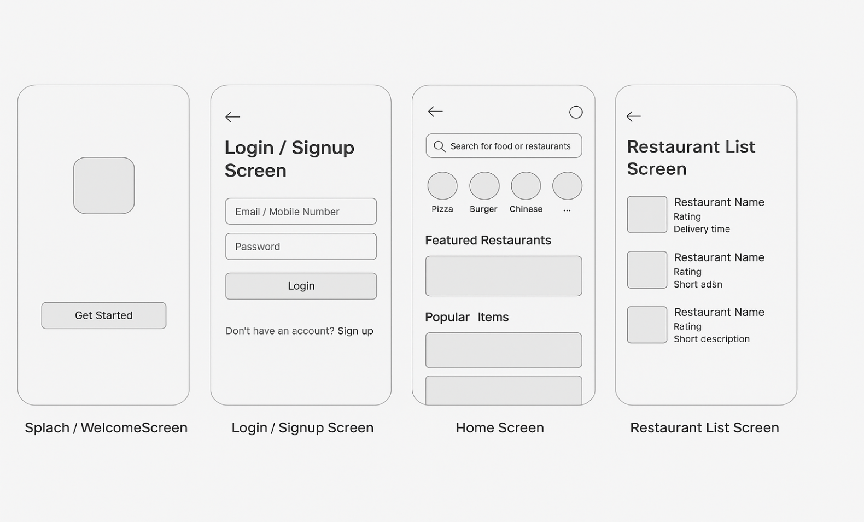

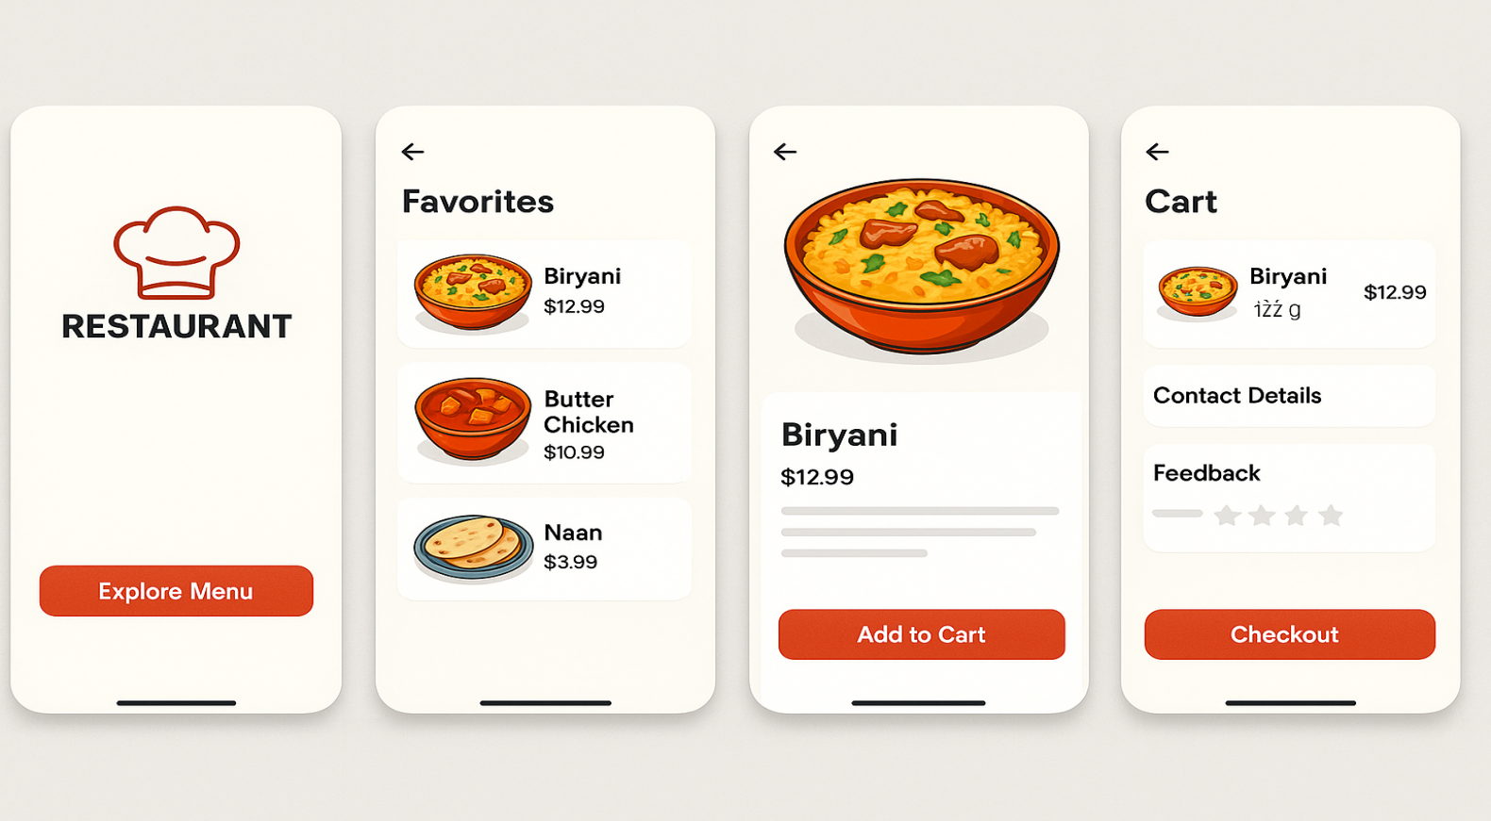

**CHAPTER 5**

**RESULTS AND DISCUSSIONS**

**5.1.PROTOTYPE**

A prototype is an early model or simulation of a product used to test and validate ideas before full-scale production. Prototypes vary in fidelity from simple sketches of a user interface to fully interactive digital models that resemble the final product. They serve to gather user feedback, identify usability issues, and refine design concepts, helping ensure that the final product meets user needs effectively. Prototyping is one of the most critical steps in the design process, yet prototypes still confuse some designers and project teams.

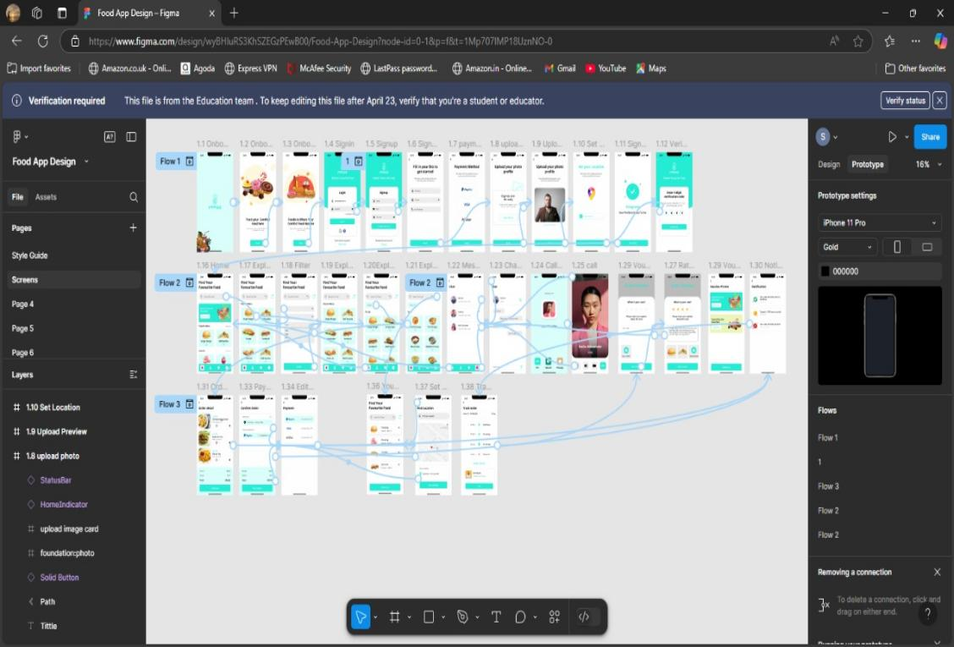

Fig 5.1 Prototyping

**5.2.SUMMARY**

The app is designed to provide a seamless and intuitive experience for users to browse, select, and order food from local restaurants.

**1. Home Screen**

* Features a search bar, location selector, and promo banners.
* Showcases food categories, popular restaurants, and trending dishes.
* Bottom navigation allows easy access to Home, Orders, Favorites, and Profile.

**2. Restaurant & Menu Screens**

* Display restaurant details (ratings, delivery time, offers).
* Menu organized into categories with clear dish descriptions and images.
* “Add to Cart” functionality with quantity selection.

**3. Cart & Checkout**

* Cart page summarizes selected items, prices, and quantity controls.
* Checkout screen includes delivery address, payment options, and promo code entry.
* Final review before placing the order.

**4. Order Tracking**

* Live order tracking with a progress bar.
* Real-time updates from preparation to delivery.
* Driver contact and livemap available.

**5. User Profile**

* Includes order history, saved addresses, payment methods, and account settings.
* Options for help & support and logging out.

**5.3.CONCLUSION**

The Online Food Ordering App UI is crafted to offer a seamless and user-friendly experience, enabling users to discover, select, and order meals with ease. The home screen features intuitive navigation, a smart search bar, and categorized food options that help users quickly find what they're craving. Restaurant pages provide detailed menus with vibrant images, descriptions, and easy add-to-cart functionality. The cart and checkout process is streamlined, supporting multiple payment methods and real-time price summaries. Live order tracking keeps users updated every step of the way, from preparation to delivery. User profiles store order history, payment details, and saved addresses for convenience. Visually, the app maintains a clean, modern aesthetic with consistent use of colors, icons, and typography. It’s designed for responsiveness across devices, ensuring a great experience on both smartphones and tablets. The UI focuses heavily on speed, clarity, and convenience, which are crucial for food delivery platforms. Overall, it creates a reliable and enjoyable journey for users, encouraging repeated use and customer loyalty.

**5.4.SAMPLE SCREENSHOTS**

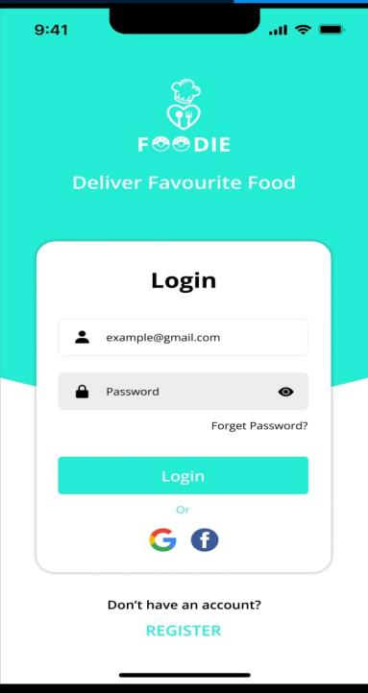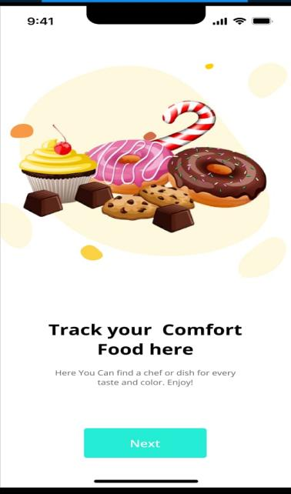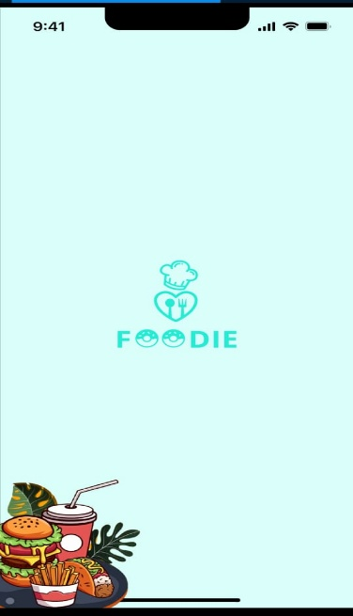

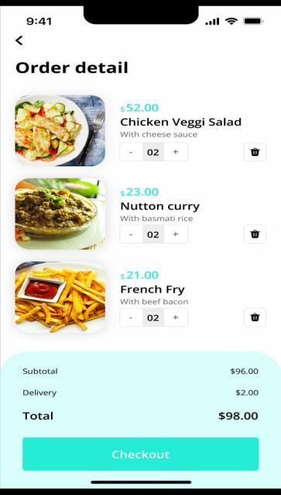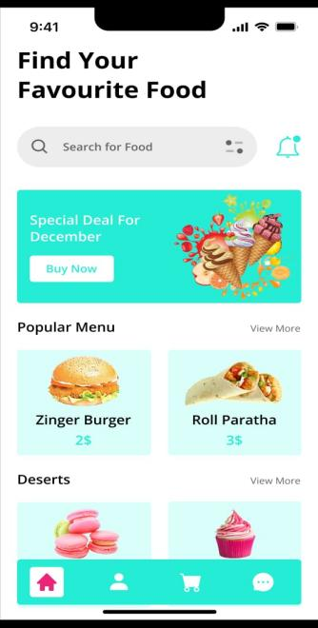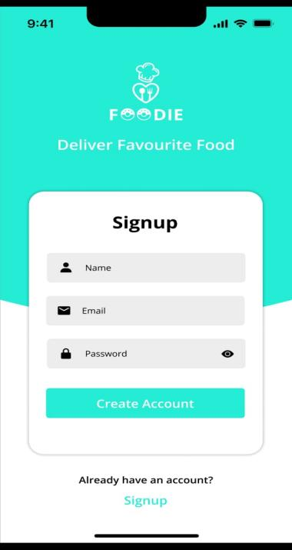

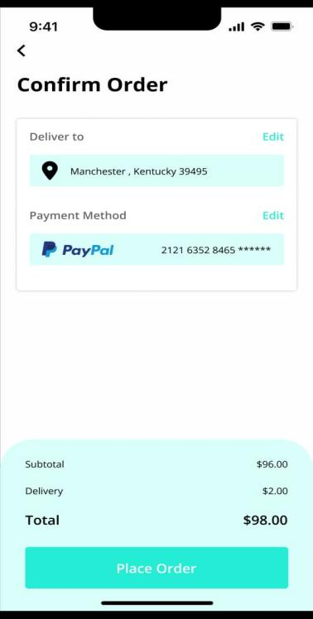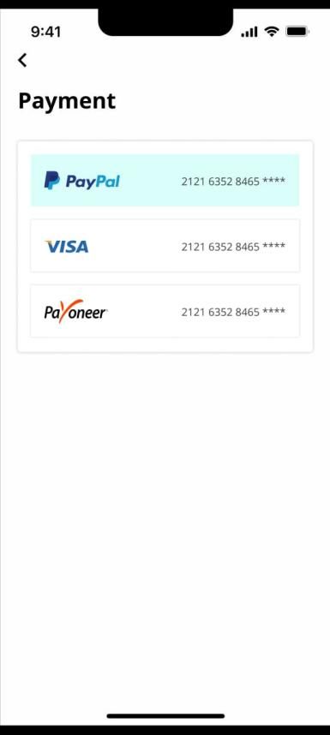

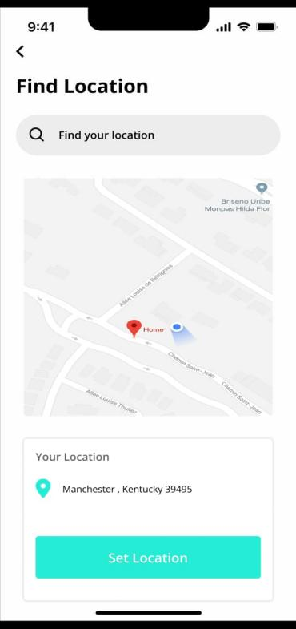

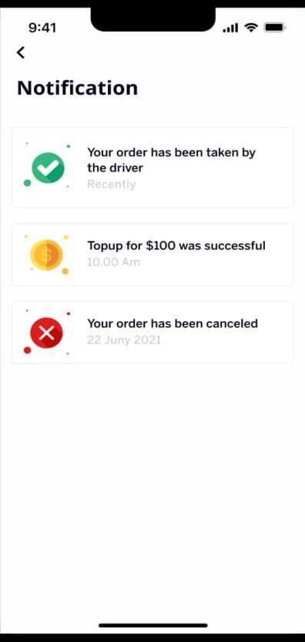

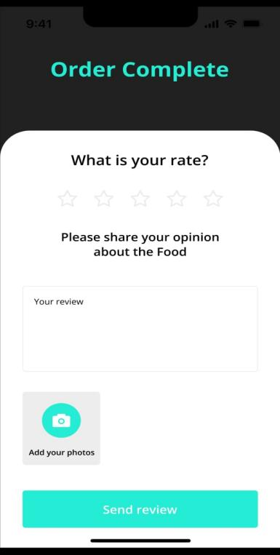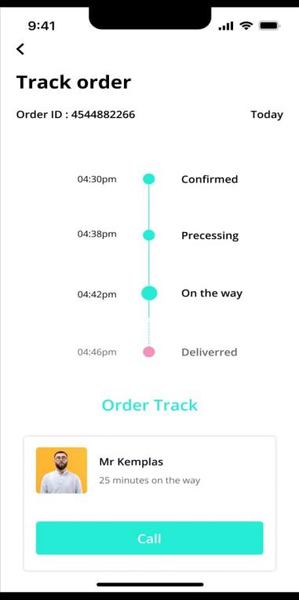

**CHAPTER 6**

**REFERENCES**

* + - Lindberg, Tilmann, Gumienny, Raja, Jobst, Birgit, & Meinel, Christoph. Is There a Need for a Design Thinking Process? Proceedings of Design Thinking Research Symposium 8 (Design 2010), pp. 243–254, 2010.
    - Krug, Steve. Don't Make Me Think: A Common Sense Approach to Web Usability. 2nd Edition, New Riders, 2005.
    - Norman, Donald A. The Design of Everyday Things. Revised and Expanded Edition, Basic Books, 2013.
    - Google. Material Design Guidelines. Retrieved from https://material.io/design
    - Apple.Human Interface Guidelines. Retrieved from <https://developer.apple.com/design/human-interface-guidelines/>
    - Figma Inc. Figma Design Tool. Retrieved from <https://www.figma.com>
    - UX Collective. UX Design Articles and Case Studies. Retrieved from <https://uxdesign.cc/>